Title Page

Flappy Turtle

– My own interpretation of Flappy Bird

Andy Nguyen

Febuary 27th, 2022

Copyright Information

Version 0.1(draft) October 10, 2005

By Mark Baldwin

Baldwin Consulting

http://baldwinconsulting.org

The Game Design Document (GDD) it the blueprint from which a computer or video game is to be built. As such, every single detail necessary to build the game must be addressed in the document (or support documents). If it’s not in the document, then it probably won’t be in the game.

Below you will find an outline for a generic Game Design Document. The problem is that no generic GDD will be able to address all the various genres for which a game may be created. For example, consider the games PacMan, SimCity and Doom. All three games required detailed design documents, but if you think about it, those documents would be entirely different! As such, when using the outline below you will find sections that will be totally meaningless to your game. But also, there will be sections that your GDD requires to describe the game. Just because it’s not in my outline, it doesn’t mean that it doesn’t belong.

The GDD is a reference document. Members of the development team will constantly be using the document to find specific information for their specific needs. Consider the size such a document may grow to in order to document every piece of the game. We don’t want the GDD to cause information overload and then become a prop under somebody’s wobbly desk. As such it is important that you organize and format the document to make it easy to use. Also note that some of these sections might not appear in the GDD itself but instead would appear in supplemental documents such as an Art Bible or Test Plan. This helps make the overall document more manageable and readable.

One last comment, a game design document is meant to be a living document. Just as when the artist changes the design of his painting every time he takes his brush to the canvas, a computer or video game evolves as code and art are created. The GDD then is the communication tool from which all the members of the team can follow that evolution.

**Document Revision history:**

|  |  |  |  |
| --- | --- | --- | --- |
| Version | Date | Author(s) | Changes |
| 0.2 | January 16, 2013 | Emile Cormier |  |
| 0.3 | January 05, 2016 | David Burchill |  |
| 0.4 | January 29, 2022 | Andy Nguyen |  |
| 0.5 | Febuary 27,2022 | Andy Nguyen |  |

*(Use word’s “update table of contents” to generate / regenerate a table of contents. )*

Table of Contents

1. Section I - Game Overview 6

1.1. Game Concept 6

1.2. Design History 6

1.3. Feature Set 6

1.4. Genre 6

1.5. Target Audience 6

1.6. Game Flow Summary 6

1.7. Look and Feel 6

1.8. Project Scope 6

1.8.1. Number of locations 6

1.8.2. Number of levels 6

Etc. 7

2. Section II - Gameplay and Mechanics 7

2.1. Gameplay 7

2.1.1. Game Progression 7

2.1.2. Objectives – What are the objectives of the game? 7

2.1.3. Play Flow – How does the game flow for the game player 7

2.2. Mechanics 7

2.2.1. Physics 7

2.2.2. Movement 7

2.2.3. Objects 7

2.2.4. Actions 7

2.2.5. Economy 8

2.3. Screen Flow 8

2.3.1. Screen Flow Chart 8

2.3.2. Screen Descriptions 8

2.4. Game Options 9

2.5. Replaying and Saving 9

2.6. Cheats and Easter Eggs 9

3. Section III – Story, Setting and Character 9

3.1. Game World 9

3.1.1. General look and feel of world 9

3.1.2. Area #1 9

3.1.3. Area #2 9

3.2. Characters 9

3.2.1. Character #1 9

3.2.2. Character #2 9

4. Section IV – Levels 9

4.1. Level 10

5. Section V - Interface 10

5.1. Visual System 10

5.1.1. HUD - What controls 10

5.1.2. Menus 10

5.2. Control System 10

5.3. Audio 10

5.4. Music 10

5.5. Sound Effects 10

6. Section VI - Artificial Intelligence 10

6.1. Opponent AI 10

7. Section VII – Technical 10

7.1. Target Hardware and operating system 10

7.2. Supported game controllers and peripherals 10

8. Section VIII – Game Art 11

8.1. Concept Art 11

8.2. Style Guides 11

8.3. Characters 11

8.4. Environments 12

8.5. Miscellaneous 12

# Section I - Game Overview

## Game Concept

The big picture of the game is that the turtle is endlessly swimming and trying not to die by crashing into the columns. The player will earn one point by going through the column and not dying in the process. The main quest is trying to gain as many points as possible, and the game will go on endlessly after every 10 points( starting at 20 ); the game will randomly pick a challenge for the player from the challenges category (Inverse, Upside down)

## Design History

January 29th – First Game Concept

## Feature Set

N/A

## Genre

**An arcade-style game** in which the player controls the turtle, which moves persistently to the right.

## Target Audience

The target audience is casual gamers who want to burn time in a fun way and retro gamers.

## Game Flow Summary

The Player will control a turtle that is constantly going down and to move it up, the player has to press the spacebar the move the turtle through the pillars and not crash into the pillar. The Flow of the game will gradually faster and harder due to the more obstacle and challenges.

## Look and Feel

The Basic Look and Feel will be of an arcade game, very old-school and retro similar to the original game Flappy Bird which took inspiration from Super Mario.

## Project Scope

A summary of the scope of the game.

### Number of locations

There will be 2 different locations for the game, underwater ruins and city with the night sky

### Number of levels

There will be only one level for the game but the user can select different backgrounds

### Etc.

Players can select different skins for the turtle upon unlocking it through gameplay

# Section II - Gameplay and Mechanics

## Gameplay

### Game Progression

The Game will start at the default starting location and begin swimming through the pillars after a 20 points mark, a change in gameplay will be implemented; specifically reverse and inverse gameplay and new enemies will spawn

### Objectives – What are the objectives of the game?

The Main Objective is trying to obtain the highest score possible and obtain the new looks for the turtle

### Play Flow – How does the game flow for the game player

The game flow goes faster depends on the points the player obtains during the game

## Mechanics

### Physics

The Physics for the game is simple, the turtle will always go in a direction and going down and the controls makes the turtle go up (unless in inverse gravity mode which the controls and the general gravity flipped around)

### Movement

#### General Movement

The General Movement is the turtle constantly moving in a direction and the movement of the turtle flaps

#### Other Movement

N/A

### Objects

#### Moving Objects

Pillars that Spawns and Sharks Spawns Randomly

### Actions

#### Switches and Buttons

Space Bar – Makes the turtle goes up/down

### Economy

N/A

## Screen Flow

### Screen Flow Chart

A graphical description of how each screen is related to every other

### Screen Descriptions

What is the purpose of each screen?

#### Title Screen / Main Menu Screen

Shows the name of the Game and the buttons for the user to click in order to play the game

#### Options Screen

Select Play or View High Scores or Exit

#### High Score Screen

View High Scores

#### Pause Screen

Pauses the game for the user with the ability to return to the main menu

#### Start Screen

Waits for the user input to start the game

#### Game Screen

Actual Gameplay

#### Etc.

## Game Options

What are the options and how do they affect game play and mechanics?

N/A

## Replaying and Saving

N/A

## Cheats and Easter Eggs

N/A

# Section III – Story, Setting and Character

## Game World

### General look and feel of world

### Area #1

#### General Description

Underwater ruins with the specific pillar texture

#### Physical Characteristics

Normal Gravity, Scroll Speed

### Area #2

#### General Description

Night Sky City with the specific pillar texture

#### Physical Characteristics

Normal Gravity, Scroll Speed

## Characters

### Character #1

A Turtle Swimming through the ocean trying to find its way home

### Character #2

Sharks trying to stop the turtle by crashing into it

# Section IV – Levels

## Level

There will be only one level for the game and the game will go on endlessly

# Section V - Interface

## Visual System

### HUD - What controls

Select options with keys

### Menus

Menu Option to Play/ View Leader Boards

## Control System

Press Spacebar to make the turtle go up/down depending on the current gravity

## Audio

Classic Flappy Turtle sounds

## Music

Low Background sound

## Sound Effects

Turtle swimming sound

Point sound effect

Death sound

# Section VI - Artificial Intelligence

## Opponent AI

Sharks will randomly spawn to attack the turtle in a line

# Section VII – Technical

## Target Hardware and operating system

Windows

## Supported game controllers and peripherals

N/A

# Section VIII – Game Art

Only show concept art here (rough sketches)

## Concept Art



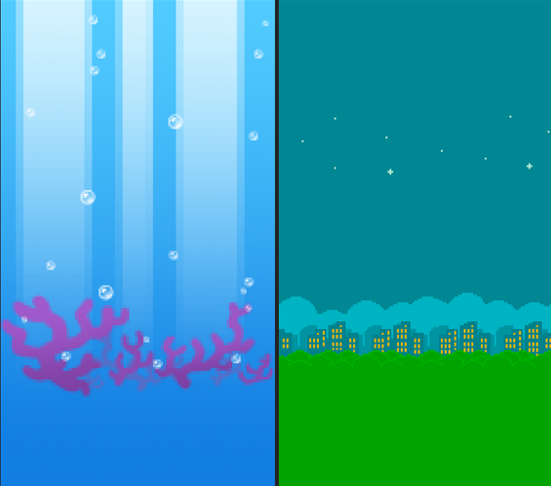

## Style Guides

## Characters

## Environments

## Miscellaneous

To be Added